

OPEN TO ALL SOUTH AUSTRALIANS
Artist’s name & address
NAME……………………………………………………
ADDRESS………………………………………………
……………………..………………………………………
PHONE …………………………………………………………….
EMAIL……………………………………………………
ABN No ……………………………. Hobbyist Y- N
RSASA member ………… Non-member……
No. of entries ..……………………………………………..
Total Entry fees ……………………………………………. Payment by cash or Bank transfer or cheque or Postal Order (please circle) (NO CREDIT CARDS)
I (name) …………………………………………………………….. agree to allow the image/s of my work/s to be used for publicity purposes and attest that the work is my own original unassisted work, is for sale & belongs to me.
(Please turn over)

Unselected work entered for a previous S.A.P. may be resubmitted if it/they are the artists own original work, have not been copied from others photos or works, have not been sold, done in a class, nor received assistance.
The urgency of reducing carbon emissions can no longer wait on government, foreign powers or anyone else to take responsibility. We must do what we can – NOW.
According to The Climate Change Authority
“Net zero by 2035 is the only target available to Australia that provides a strong chance of contributing to holding global heating below
2 degrees .
The higher the Government sets our climate target, the more they will be doing to help keep Australians safer.” September 2025
www.solarartprize.com
www.rsasaarts.com.au
Facebook Solar Art Prize
Email solarartprize@gmail.com
Enquiries –Pip Fletcher- 0431369095
With special thanks to
Anonymous donors.
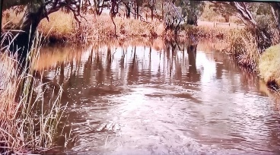
18th Solar Art Prize
Caring for Our Planet
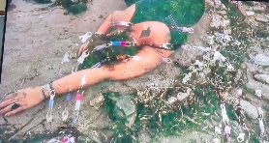

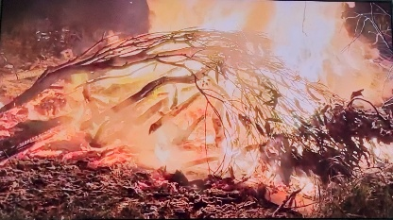
Unmet Whispers -– a multi media film by
Libby Tozer winner of the 17th Solar Art Prize
The Royal South Australia Society of Arts Gallery
Institute Blg. North Tce. cnr. Kintore Ave. Adelaide
Tues 30th March – 25th April 2027
Official opening & prize giving 4th April
Total Prize money
$33,100
Non acquisitive
All mediums accepted
Entries Close Feb.9th 2027



THEME: Climate change, nature and the environment; or environmentally aware people or thought-provoking images OR carbon free travel.
Winners receive vouchers for discount on products to reduce carbon footprint.
Eg Solar Q Cell Panels fully installed & honoured by Natural Technology Systems in SA unless the winners chose an alternative supplier willing to honour them. Other products could include solar hot water, batteries, solar camping equipment, insulation, E.V.’S, bicycles or metro tickets.
Prizes are transferrable to family or friends.
Overall Prize – $7,000 voucher or $1,000 cash
Plus 1 year RSASA membership
RSASA’S SPECIAL 170TH YEAR PRIZES
The really, really, Really, LOW CARBON TRAVEL & TRANSPORT PRIZE $7,000 voucher – or $1,000 cash Historical, Contemporary or Futuristic - Horse, camel, oxen, cycle, tuk-tuk pedal power, row boat, sailing ships, galleys, gliders, donkey carts, carriages or E.V.’S, carrier pigeons etc (Quote carbon emissions cost if possible.)
YOUTH Prize- $2,000 Voucher or $200 metro tickets
Youth 2nd Prize - $100 metro tickets.
Section Prizes – Vouchers of $4,000 or $100 cash
1. Climate Change- results or causes or Satire or caricatures expressing people’s Irresponsibility.
2. People or their actions who help the environment.
or portraits of local people who take responsible action for combatting climate change.
3. Aussie Animal Sanctuary Prize-Wild Nature Environment – Land or seascape / underwater world / wild, endangered or threatened fauna or flora.
Hanger’s Choice - A Voucher of $4,000 or $100 cash
Plus 10 x $100 Metro Tickets for Merits
Prizes at judges’ discretion. No-work receives more than one prize. Peoples’ Choice to be announced.
ENTRY FEES – according to size including frame & stands.
$25 – average– less than 1 square m. 2D & 3D base, $35 – large size- 1-2 square metres
$50 – very large size - 2-6 square metres
RSASA MEMBERS- $10 DISCOUNT PER ENTRY
3D work must safely stand-alone. Weight limit 75kg.
Entry fees may be paid by bank transfer
or in cash at the RSASA desk. (Cheques or postal orders, made out to ‘Solar Art Prize’,).
Credit cards are not accepted.
Bank transfers to BSB 633-000 138486352
Submit entry form & non-refundable entry fee with high quality A4 image labelled on the back with name & title for selection & publicity
& post to PO Box 721 North Adelaide 5006 by 3/2/27
If emailing a jpeg image in place of posting an actual photo, email solarartprize@gmail.com
& add $5 to the entry fee for processing
with signed & completed entry form.
Selection will be made from hard copy photos.
Optional statements describing the relevance of the subject must be less than (>)20 words or it will be cut.
Titles must be less than 5 words.
Sale of work will be at the artist’s nominated price.
All works must be for sale.
Diptychs or triptychs will only be sold as one piece.
Artists are responsible for their own insurance.
A 30% commission will be retained by the RSASA.
ALL MEDIUMS ACCEPTED
All work must be the original creation of the artist. Copies, A1 and assisted works are unacceptable.
Selection & judging is anonymous by independent judges on relevance & artistic merit - their decision is final.
You will be notified of selection by March 9th 2027
(ph. 0431 369 095 if you haven’t heard by 12/3/27).
18th Solar Art Prize – ENTRY FORM
Title……………………………………………………………………
Medium………………………………………………………………
Section………………………………………………………………
Size (ht x w).………………… ……………cm Price……………
Title……………………………………………………………………
Medium………………………………………………………………
Section………………………………………………………………
Size (ht x w).………………… ……………cm Price……………
Title……………………………………………………………………
Medium………………………………………………………………
Section………………………………………………………………
Size (ht x w).………………… ……………cm Price……………
Title……………………………………………………………………
Medium………………………………………………………………
Section………………………………………………………………
Size (ht x w).………………… ……………cm Price…………..
(Please turn over)

