

**16th SOLAR ART PRIZE**  
 **Caring For Our Planet**

OPEN TO ALL SOUTH AUSTRALIANS

Artist’s name & address

NAME…………………………………………………………….

ADDRESS…………………………………………………………  
  
……………………..……………………………………….………..

PHONE …………………………………………………………….

EMAIL……………………………………………………………...

ABN No ……………………………. Hobbyist …………

RSASA member ………… Non-member…………  
No. of entries ..……………………………………………..   
Total Entry fees ……………………………………………. Payment by:- cash or Bank transfer –  
 BSB 633000 A/C 204452411 or cheque or Postal Order (NO CREDIT CARDS)

I………………………………………………………………………….. (name) agree to allow the image/s of my work/s to be used for publicity purposes and attest that the work is my own original unassisted work, is for sale & belongs to me.   
 (Please turn over)

Unselected work entered for a previous S.A.P. may be **resubmitted** if it/they are the artists own original work, have not been copied from others photos or works, have not been sold, done in a class, nor received assistance.

**The urgency of reducing carbon emissions can no longer wait on government, foreign powers or anyone else to take responsibility. We must do what we can – NOW.**

[www.solarartprize.com](http://www.solarartprize.com)  
[www.rsasaarts.com.au](http://www.rsasaarts.com.au)  
**Facebook** Solar Art Prize  
**Email** [solarartprize@gmail.com](mailto:solarartprize@gmail.com)  
Enquiries –Pip Fletcher- 0431369095

**With special thanks to  
 Anonymous donors.**



**ENTRY FORM**   
16th Solar Art Prize –  
 Caring for Our Planet

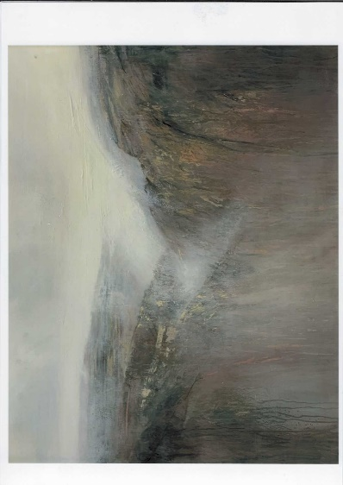

Terry McDermott – Terra Mater Overall winner of 15th Solar Art Prize

The Royal South Australia Society of Arts Gallery  
 Institute Blg. North Tce. cnr. Kintore Ave. Adelaide  
 23/3/25 - 20/4/25

**$44,000** total prize value

 **Non acquisitive – prizes at the Judges’ Discretion**All mediums accepted **Entries Close** Feb. 4th 2025  
or post office stamped January 31st 2025

**THEME:** Climate change, nature and the environment; expressed through landscapes, seascapes, wild fauna or flora or environmentally aware people or thought-provoking images**.**

**Winners receive vouchers** for discount on Solar Q Cell Panels or solar hot water or battery or Solar camping equipment - All fully installed. **Discounts will be honoured by the Natural Technology Systems unless the winners chose an alternative supplier willing to honour them, these could include E.V.’S or Bicycles.  
 Prizes are transferrable to family or friends in SA.**

**Overall Prize** – **$8,000 voucher or $1,000 cash**Plus 1 year RSASA membership  
**2nd Overall Prize** - **$6,000 voucher** or **$500 cash   
WILD NATURE PRIZE. Beauty of the natural environment. -$5,000 voucher or $250 cash  
All other prizes have $100 cash alternative  
No-one receives more than one prize.  
Section Prizes** – **Vouchers of $4,000  
1. Climate Change**- results or causes or **Satire** or caricatures expressing people’s Irresponsibility. **2. People** in action **who help the environment**.   
or the actions people take to combat climate change  
or  **portraits** of local people who take responsible action for combatting climate change - taken from life,  
**3. Natural Environment** – Land or seascape / underwater world /wild, endangeredor threatened fauna or flora.  **4. The Hanger’s Choice Prize  
5. Aussie Animal Sanctuary Prize.  
6. People’s Choice Prize  
Plus 10 x $100 Metro Tickets for**  
**Merits or Material Prizes** - **oil/acrylic/ encaustic/mixed media** /**works on paper- watercolour, ink, pastel, printmaking/drawing/photography/videos/installations/textiles/ tapestry/sculpture/3D/ recycled materials/illustrated books/ jewellery & others.   
Prizes at judges’ discretion  
ENTRY FEES –** according to size including frame & stands. **$5 discount for RSASA MEMBERS   
$15 – less than an A4 (60square cm) 2D or 3D base  
$25 – average size – less than 1 square m. 2D &** 3D base, **$35 – large size- 1-2 square metres   
$50 – very large size - 2-6 square metres**3D work must safely stand-alone. Weight limit 75kg.Entry fees may be paid by bank transfer **or** in cash at the RSASA desk. (Cheques or postal orders, made out to ‘Solar Art Prize’, accepted depending on bank or post office policy**). Credit cards are not accepted.   
Bank transfers to BSB633-000 A/C138486352**

**Submit entry form & non-refundable entry fee with high quality A4 image** *labelled on the back with name & title for selection & publicity***& post to PO Box 721 North Adelaide 5006 by 31/1/25  
  
If emailing a jpeg image in place of posting an actual photo, email** [**solarartprize@gmail.com**](mailto:solarartprize@gmail.com) **& add $5 to the entry fee for processing with signed & completed entry form.** Selection will be made from hard copy photos.

**Optional statements** to describe the relevance of the subject must be less than (>)25 words or they will be cut.  
**Titles** must be less than 5 words.  
  
**Sale** of work will be at the artist’s nominated price.   
**All works must be for sale.**  
Diptychs or triptychs will only be sold as one piece.  
Artists are responsible for their own insurance.A 30% commission will be retained by the RSASA.

**ALL MEDIUMS ACCEPTED**   
**All work must be the original creation of the artist.** Copies and assisted works are unacceptable.  
**Selection & judging is anonymous by independent judges on relevance & artistic merit - their decision is final.  
  
You will be notified of selection by March’25**

**16**th Solar Art Prize – ENTRY FORM   
  
Title…………………………………………………………………………………  
  
Medium……………………………………………………………………..……

Section…………………………………………………………………………….  
  
Size (ht x w).………………………………………cm Price……………

Title…………………………………………………………………………………  
  
Medium………………………………………………………………………..…

Section…………………………………………………………………………...  
  
Size (ht x w)……………………………………cm Price…………………

Title…………………………………………………………………………………  
  
Medium…………………………………………………………………………

Section……………………………………………………………………………  
  
Size (ht x w)………………………………………cm Price…………

Title…………………………………………………………………………………  
  
Medium…………………………………………………………………………..

Section…………………………………………………………………………...  
  
Size (ht x w)………………………………………cm Price………………

(Please turn over)